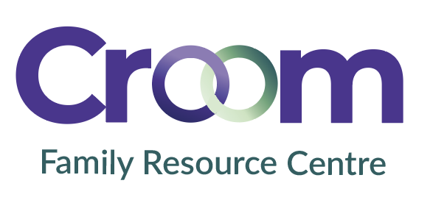

Thank you for your interest in volunteering with Croom Family Resource Centre, a local community and voluntary organisation delivering weekly meals to older and vulnerable adults.

Volunteers play a vital role in our communities. All volunteer applications are reviewed with consideration of current volunteer opportunities. The information you provide will be stored in confidence under the provisions of the Data Protection Act. Your completed form will be held securely and confidentially. Only authorized staff will have access to your information.

Personal Details

Name:__________________________________________ Mr. Mrs. Miss. Ms.

Postal Address: ____________________________________________________________________

County: __________________________

Telephone: (Home) _________________________ (Mobile) __________________________

E-Mail: __________________________________________

Birth-date: _______________________________________
Day / Month / Year

If you are involved with us as a volunteer and an emergency arises, whom should we contact?

Name: _______________________________________ Relationship: _________________________

Telephone: (Home) _________________________ (Mobile) ________________________

Equal Opportunities

Croom Family Resource Centre is committed to equal opportunities and all volunteer recruitment decisions will be based on merit, suitability for the role and experience. All volunteer recruitment decisions will not be influenced by race, colour, nationality, ethnicity, religion, sex, marital status, family status, sexual orientation, disability or age.

Croom Family Resource Centre is committed to standards of excellence in Safeguarding Vulnerable Adults. As a volunteer if you will have direct contact with vulnerable adults you will be required to complete a Garda Vetting Form. Garda vetting will be processed by Croom Family Resource Centre (via Early Childhood Ireland). Completion of the volunteer application and Garda vetting form does not signify acceptance as a volunteer.

Your Skills and Interests

1. Have you ever done any voluntary work before? Yes No
If you answered yes, please tell us a little about the experience.

2. Why do you want to volunteer with Meals on Wheels? What has motivated you to get in touch with us?

3. Do you have any particular skills or qualities that you could use in your voluntary work?

4. When are you available for voluntary work?

Totally Flexible

Tuesday | Thursday

5. How did you find out about volunteering with Meals on Wheels?

Information / Outreach meeting
Leaflet / Poster
Word of Mouth
Internet/Social Media Staff/Other Volunteer
Other ____________________
A Volunteer Centre
Local newsletter
Media Radio / Television / Newspaper
References

1.
Name: ______________________________________ Relationship: _________________________

Place of Work: ________________________________ Position: _________________________
(If applicable)

Telephone: (Home) ____________________________ (Mobile) ___________________________

E-Mail: ______________________________________

2.
Name: ______________________________________ Relationship: _________________________

Place of Work: ________________________________ Position: _________________________
(If applicable)

Telephone: (Home) ____________________________ (Mobile) ___________________________

E-Mail: ______________________________________

If you have any queries when completing this application form, please phone: 061-602878

I declare that the information I have provided is true. All my actions as a volunteer will reflect the ethos of Meals on Wheels’.

Signed __________________________________________ Date __________________________

Please return this form to Lauryn in Croom FRC or email to info@croomfrc.com at your earliest convenience

